**Question 1:**

Task 1: Working with SNS

* Creating SNS and adding user email for subscription

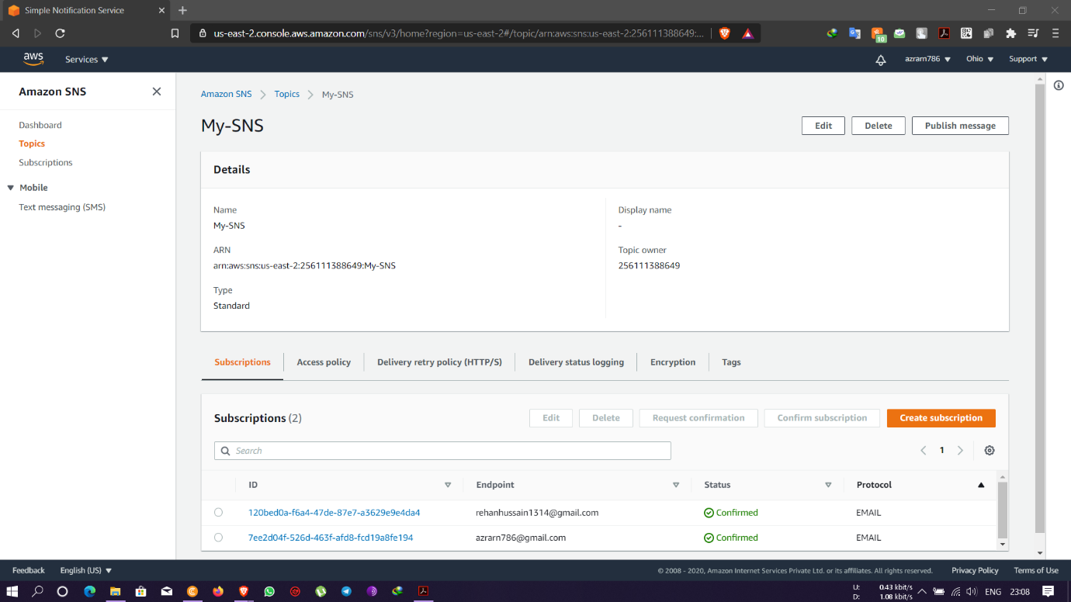

* Verification of suscriptions

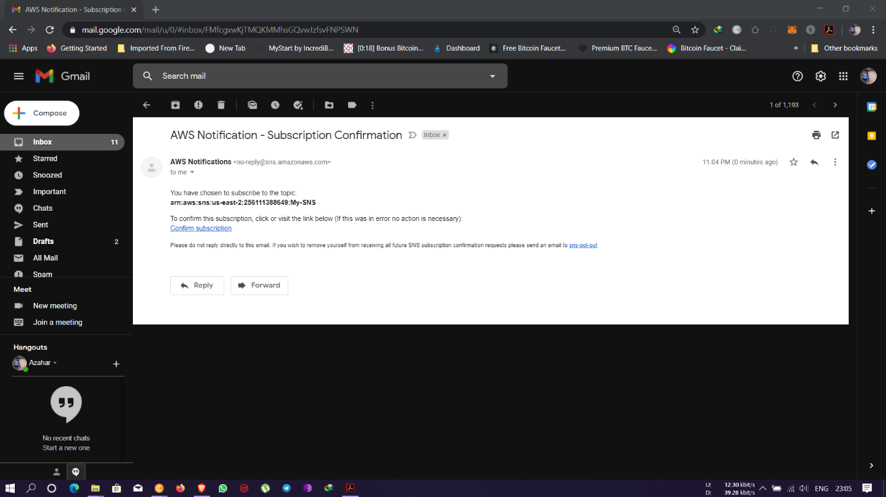

* Suscriptions notification emails

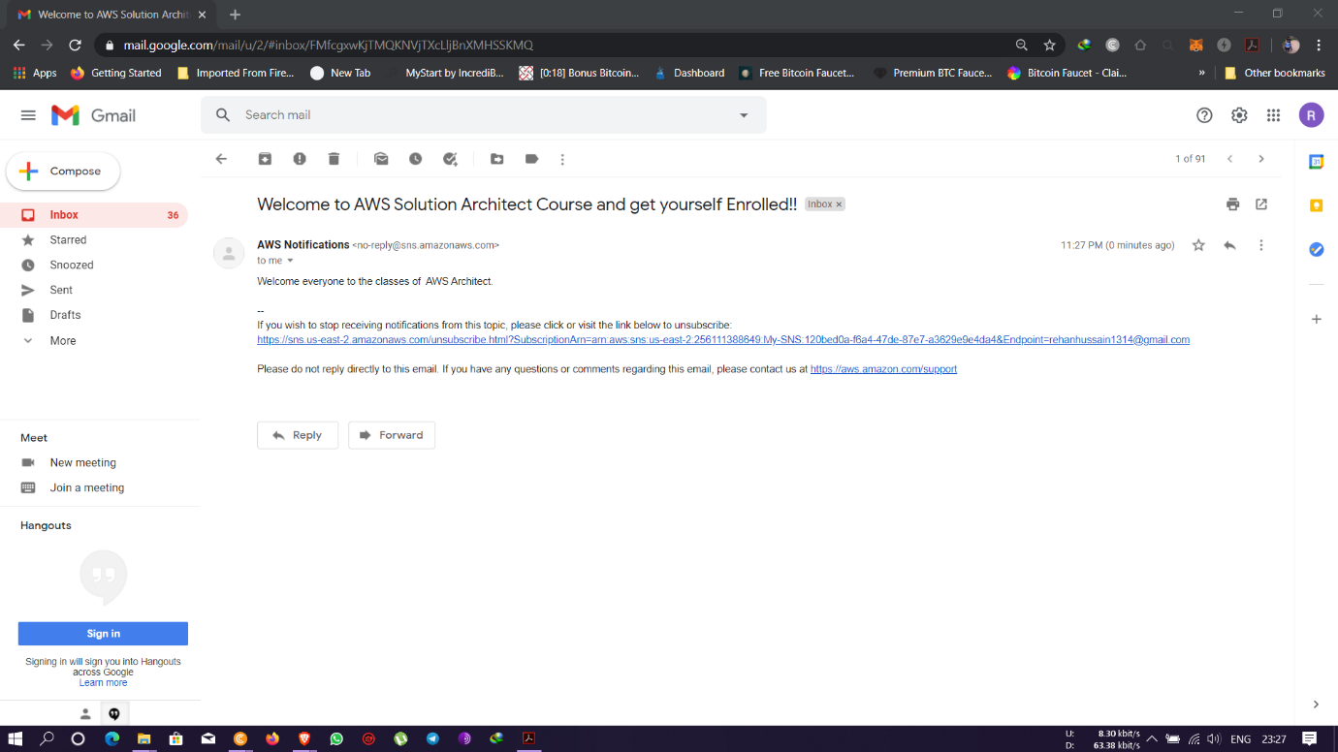

Task 2: Working with SQS

* Creating SQS queues

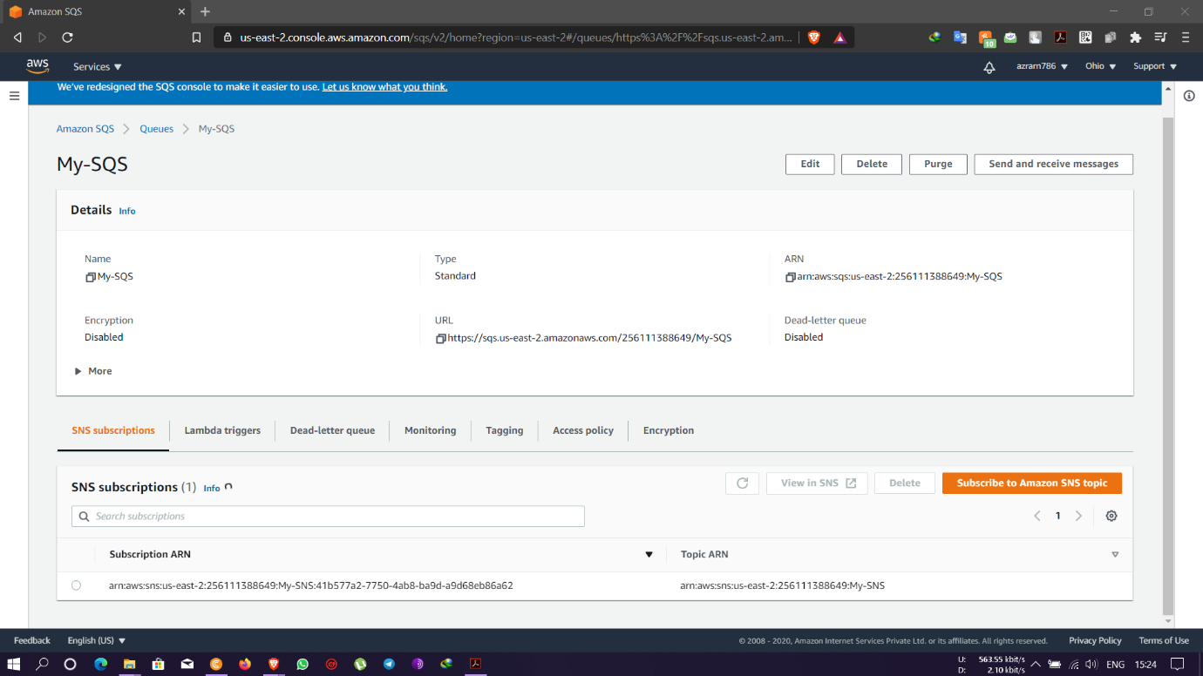

* Publishing message with SNS for SQS queues

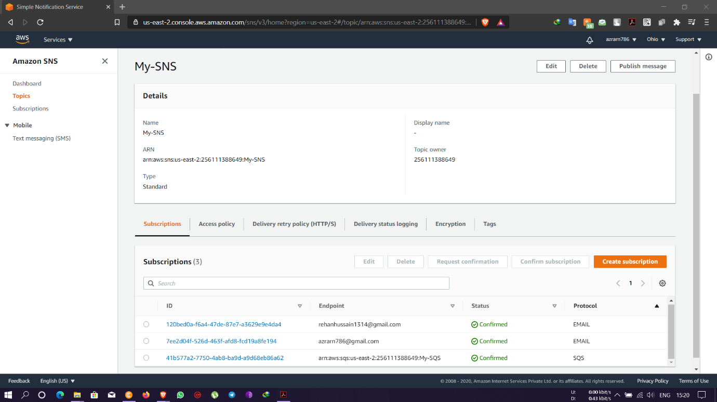

* Polling message

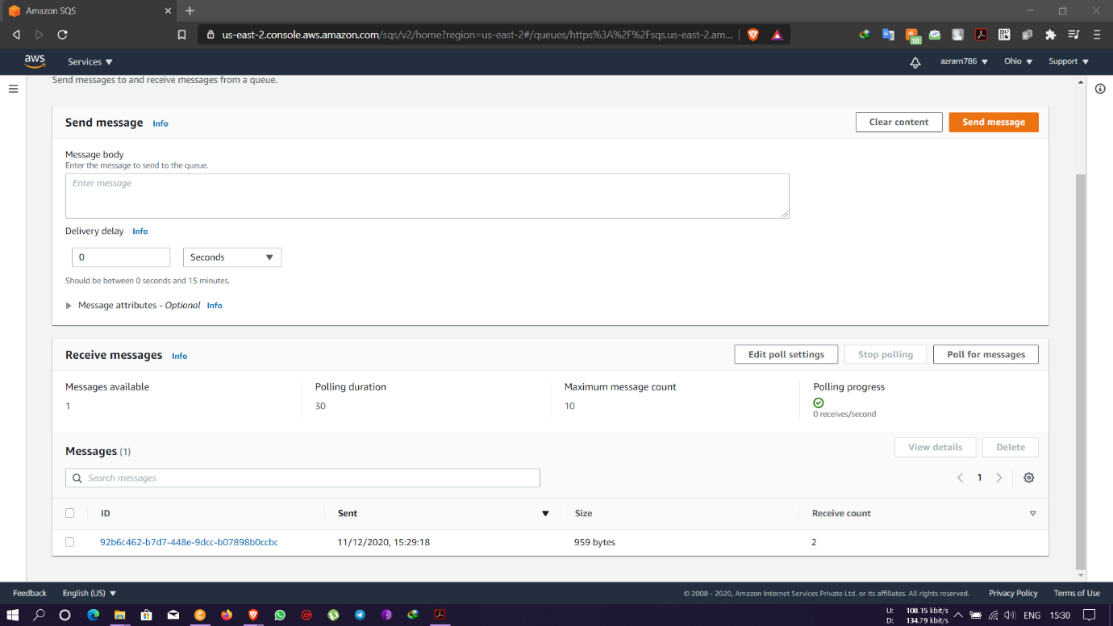

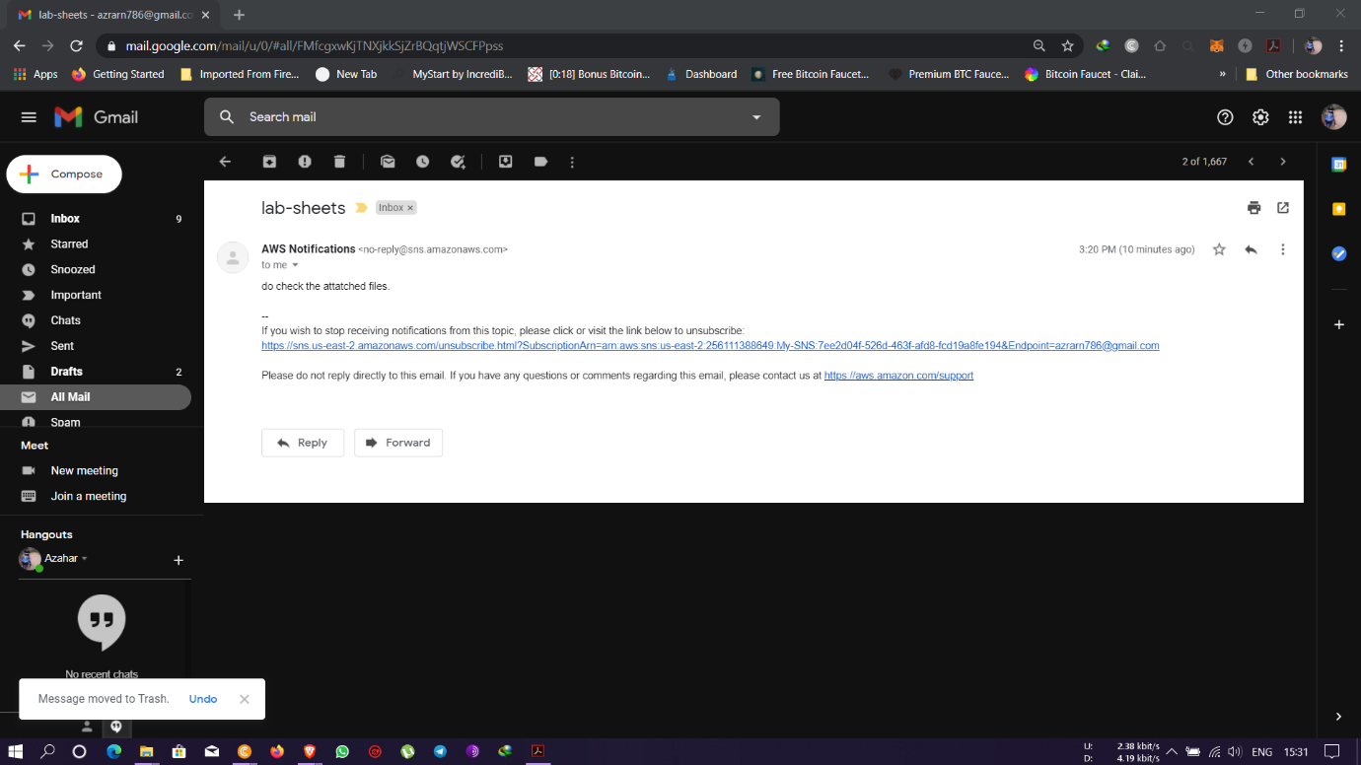

Task 3: Working with SES

* Adding emails for services

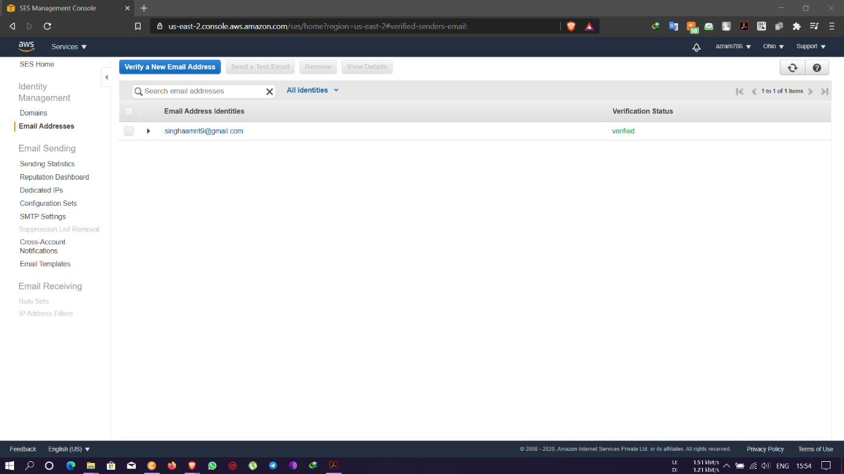

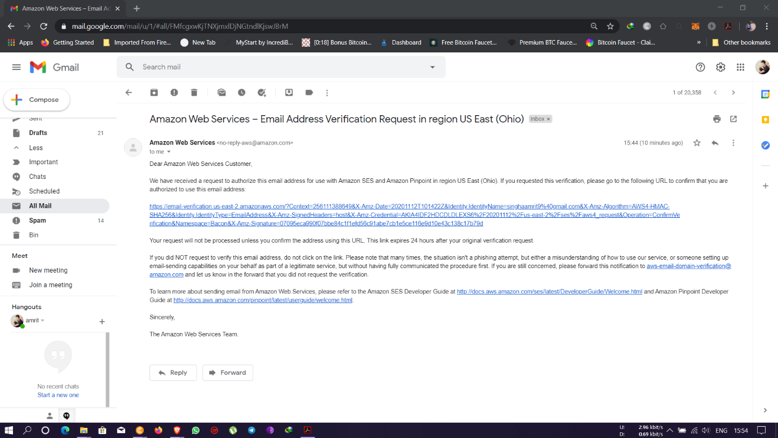

Task 4: TRIGGERING CLOUDWATCH EVENT SNS NOTIFICATION

* Creation of EC2 instance for SNS message services

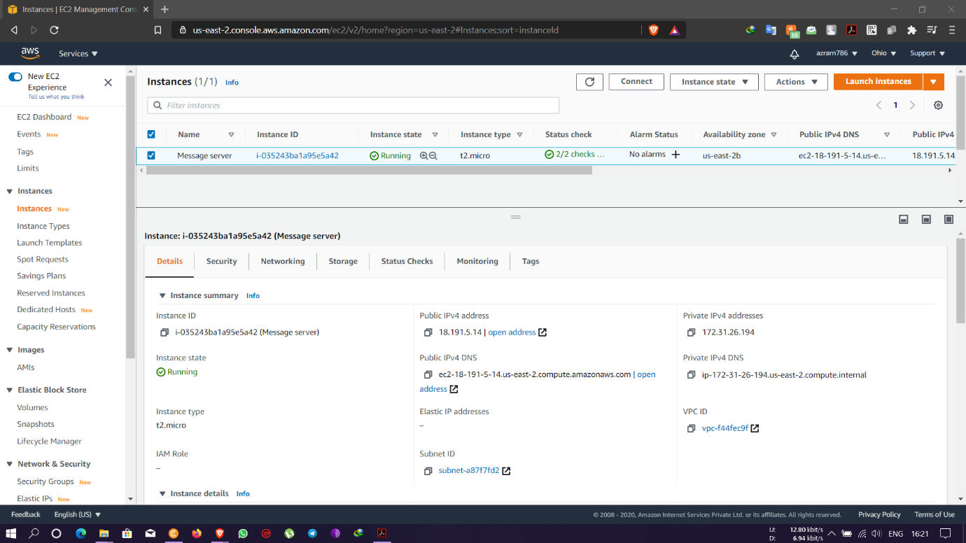

* Subscribing user to SNS

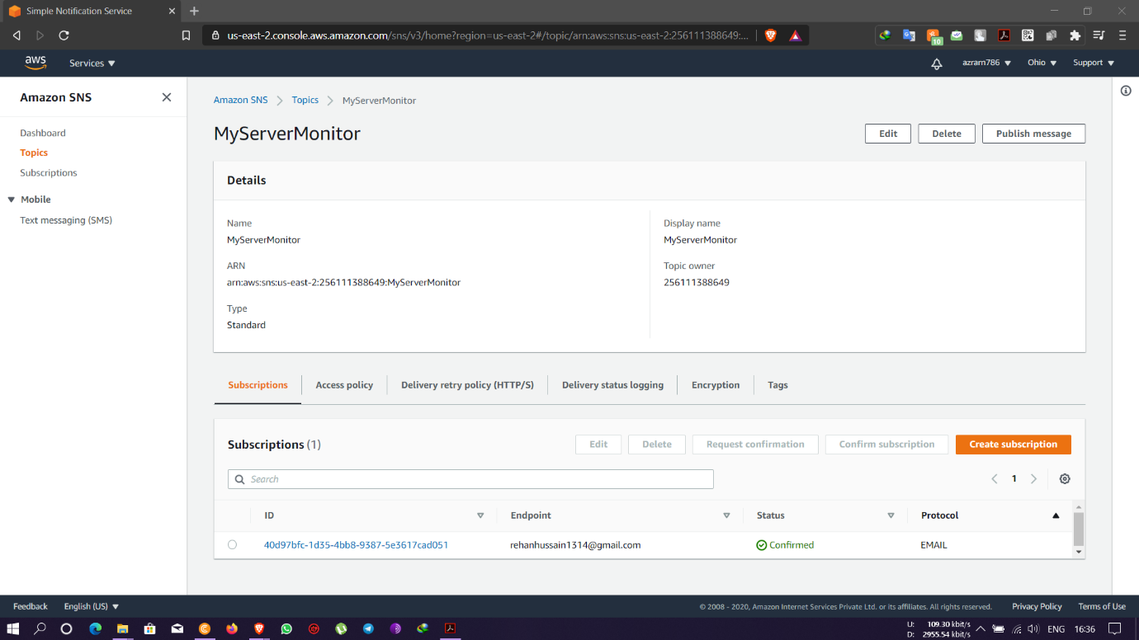

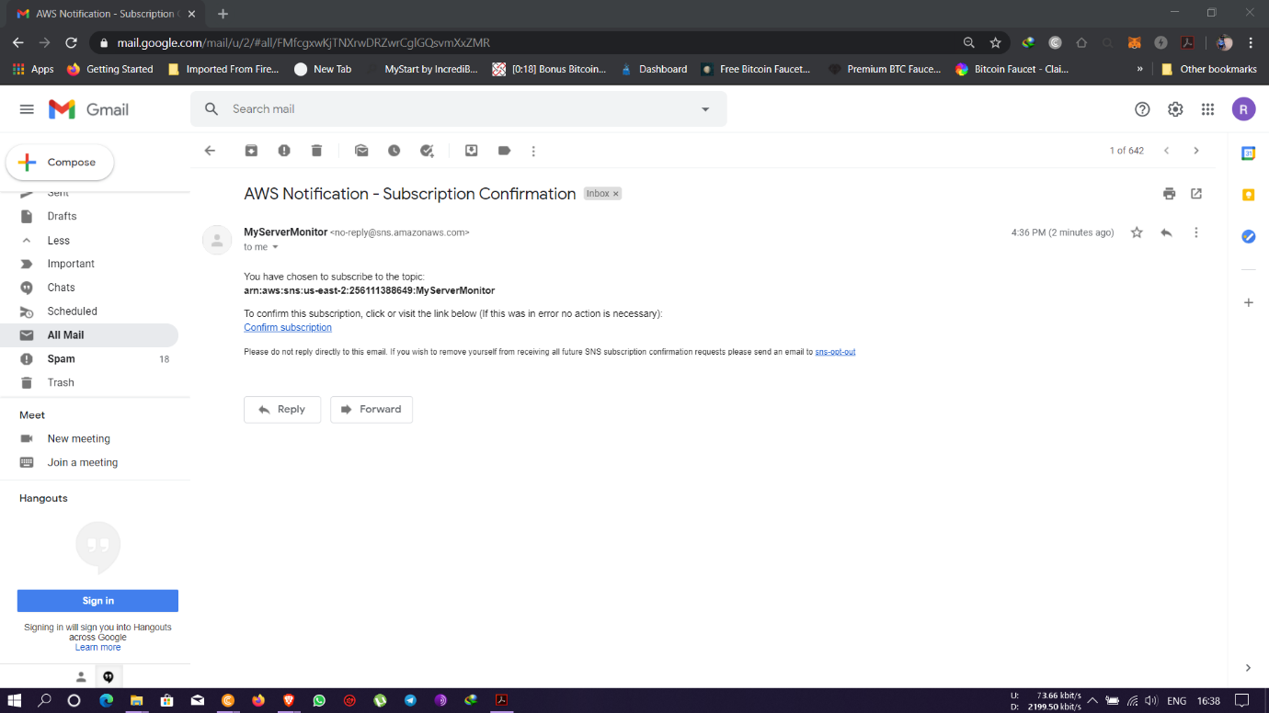

* Implementing CloudWatch rules

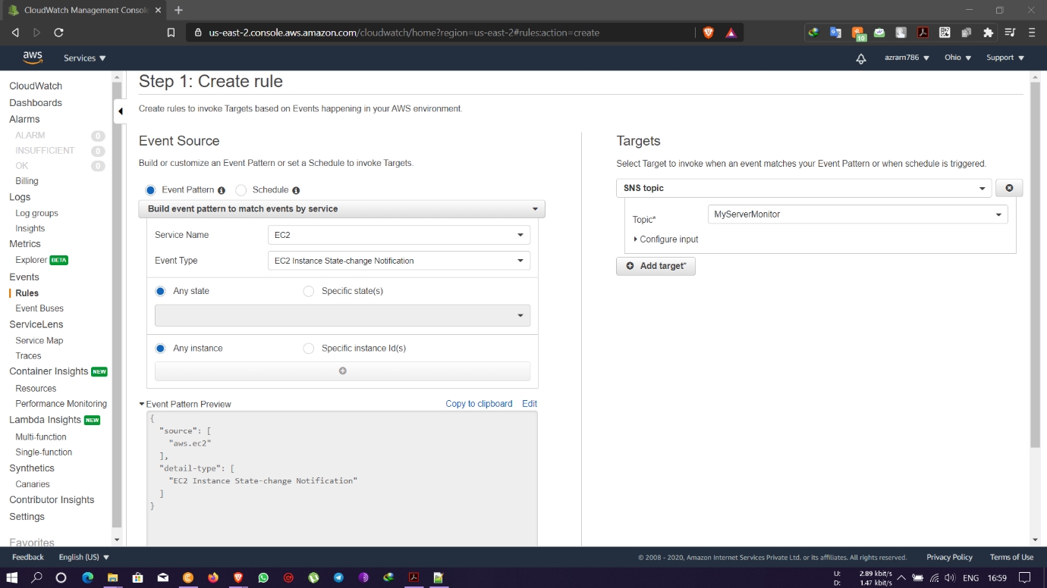

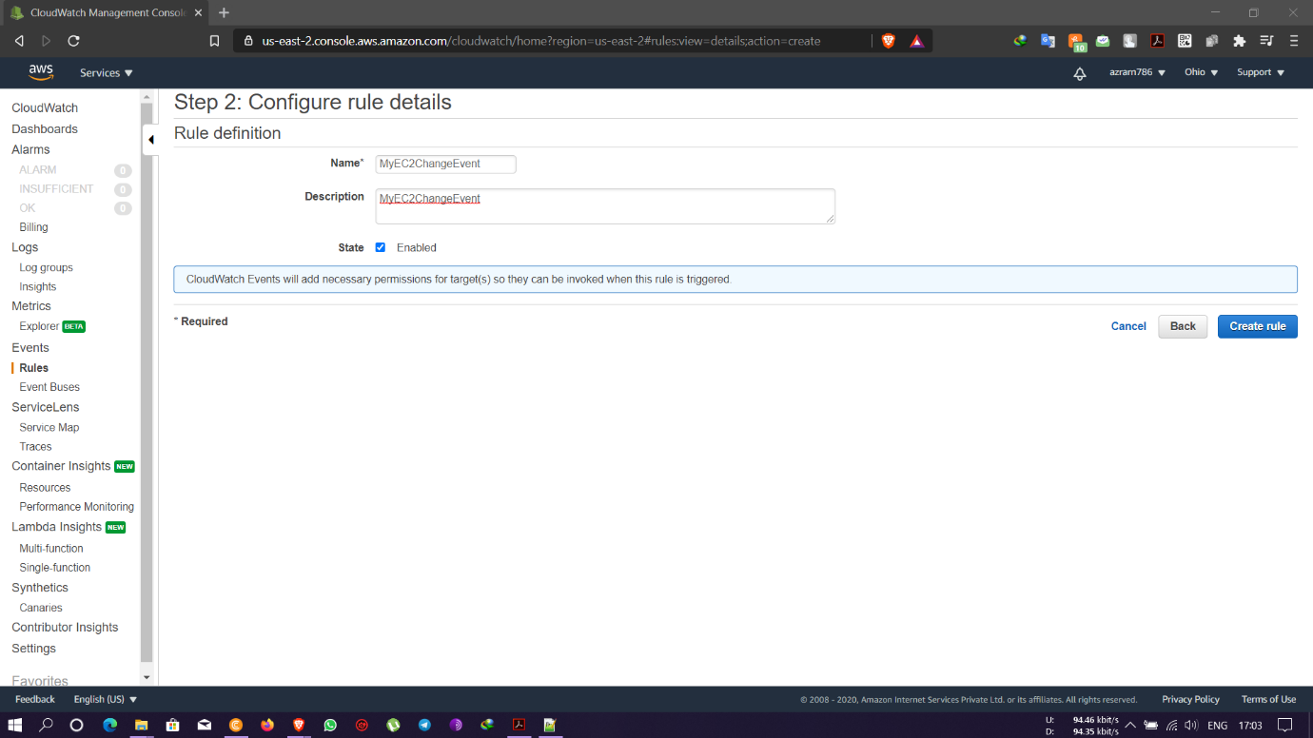

**Question 2:**

Task 1: Create a dynamo db table with minimum two disaster recovery zones and verify

replication.

* Table created with name- movies and added two replica regions- Singapore & Sydney

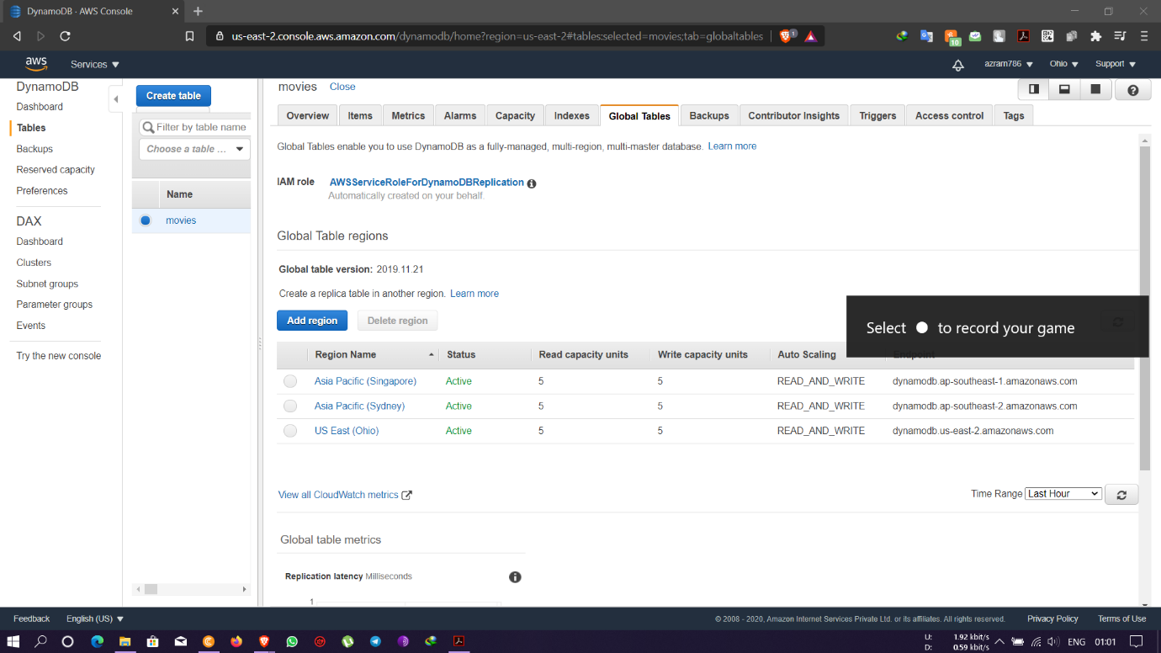

* Creation of items in the table

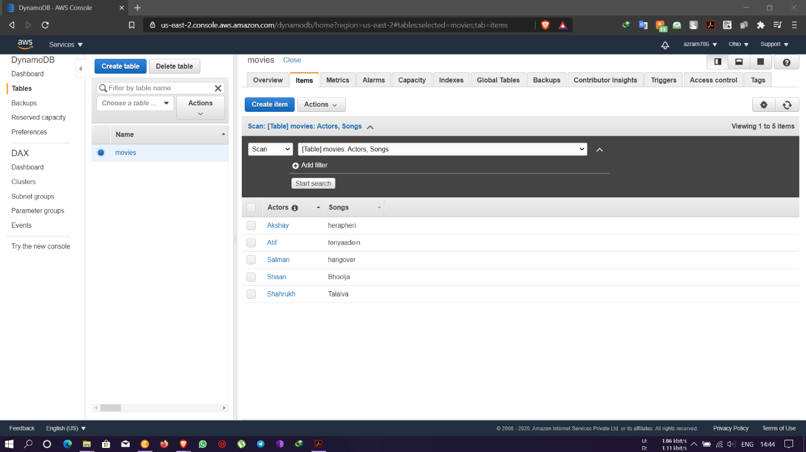

* Replica of items in Singapore and Sydney region

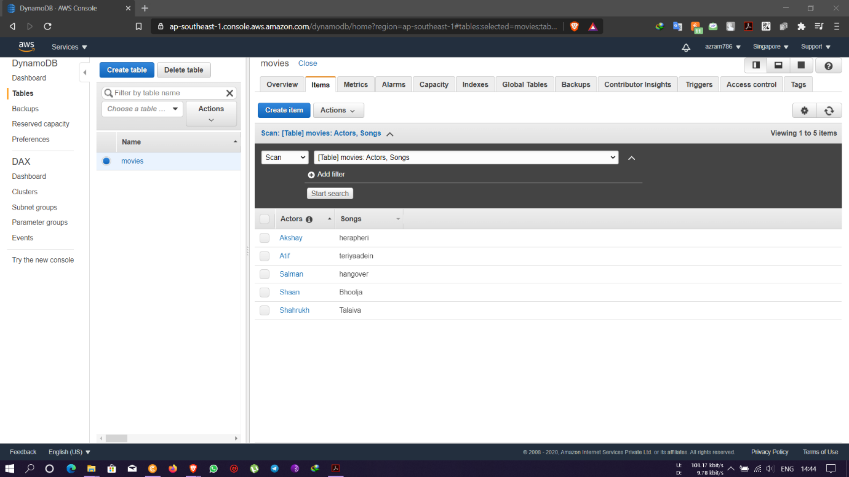

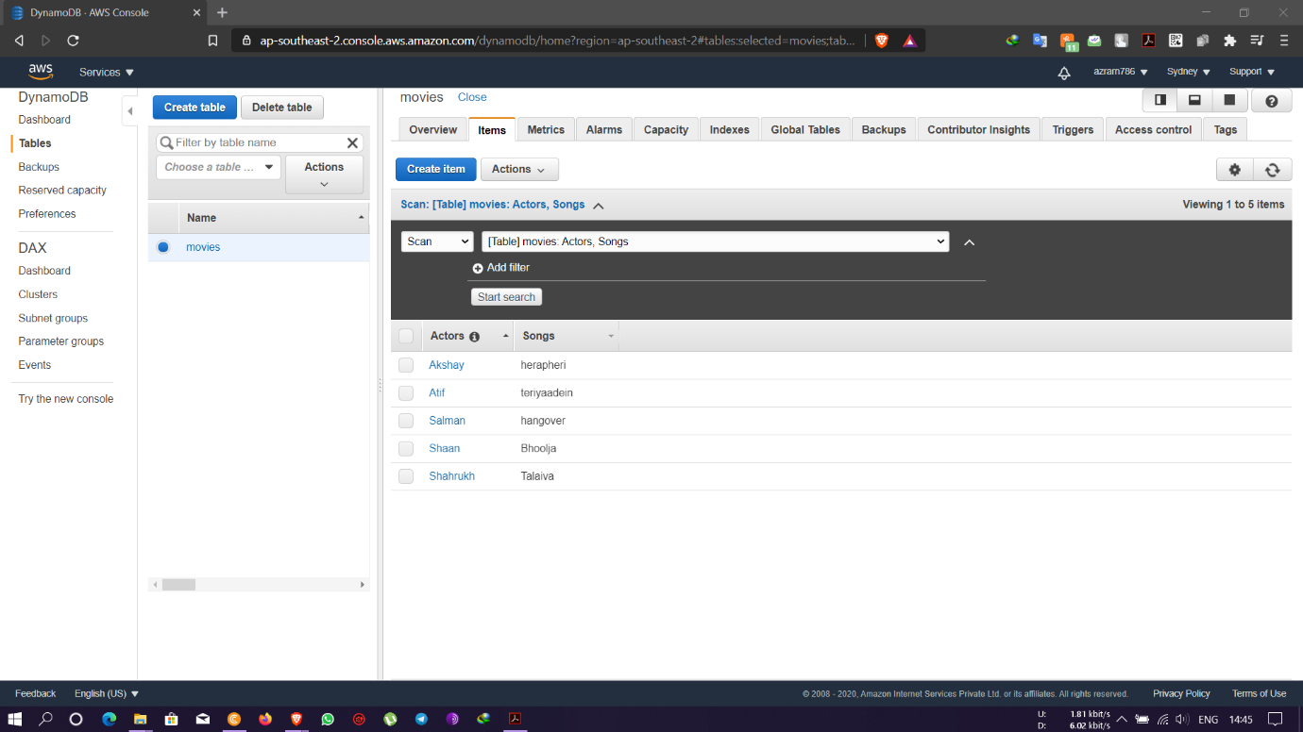

* Search query of different items in the table

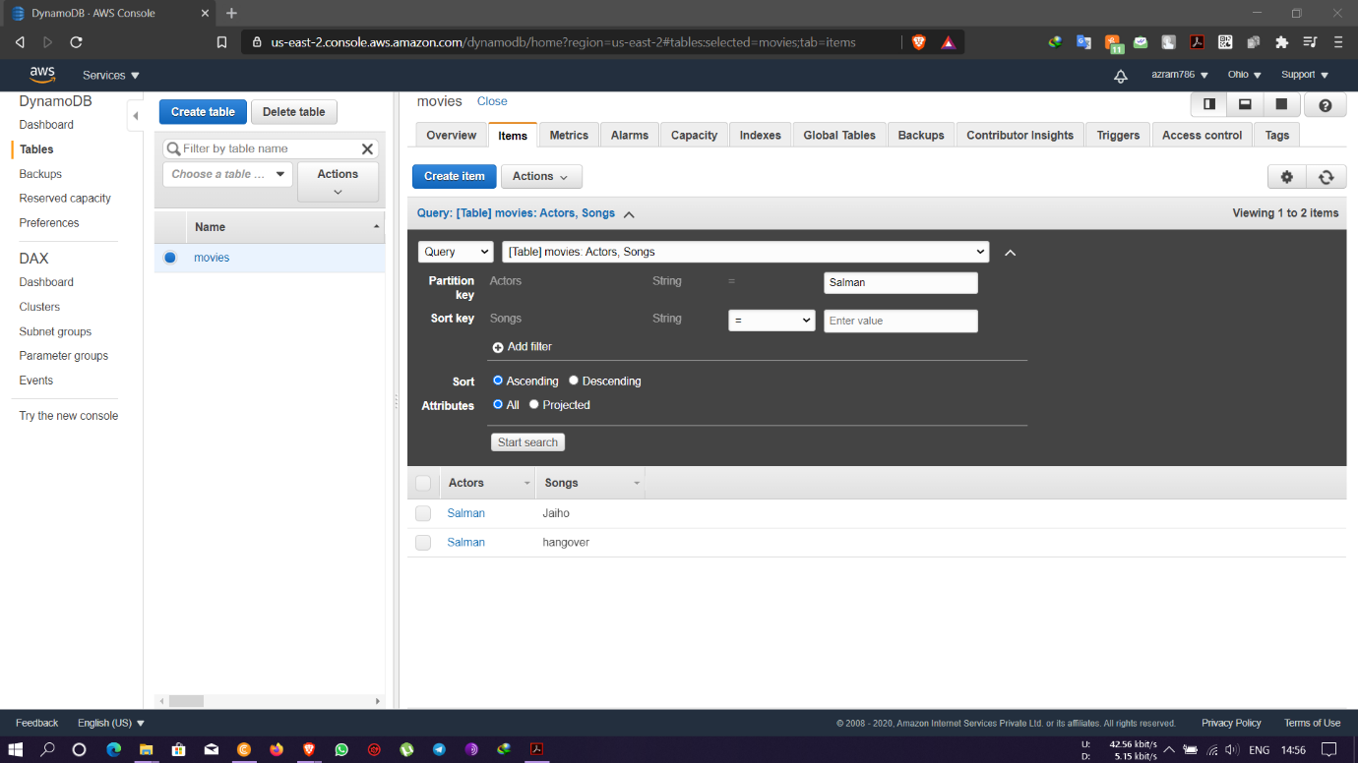

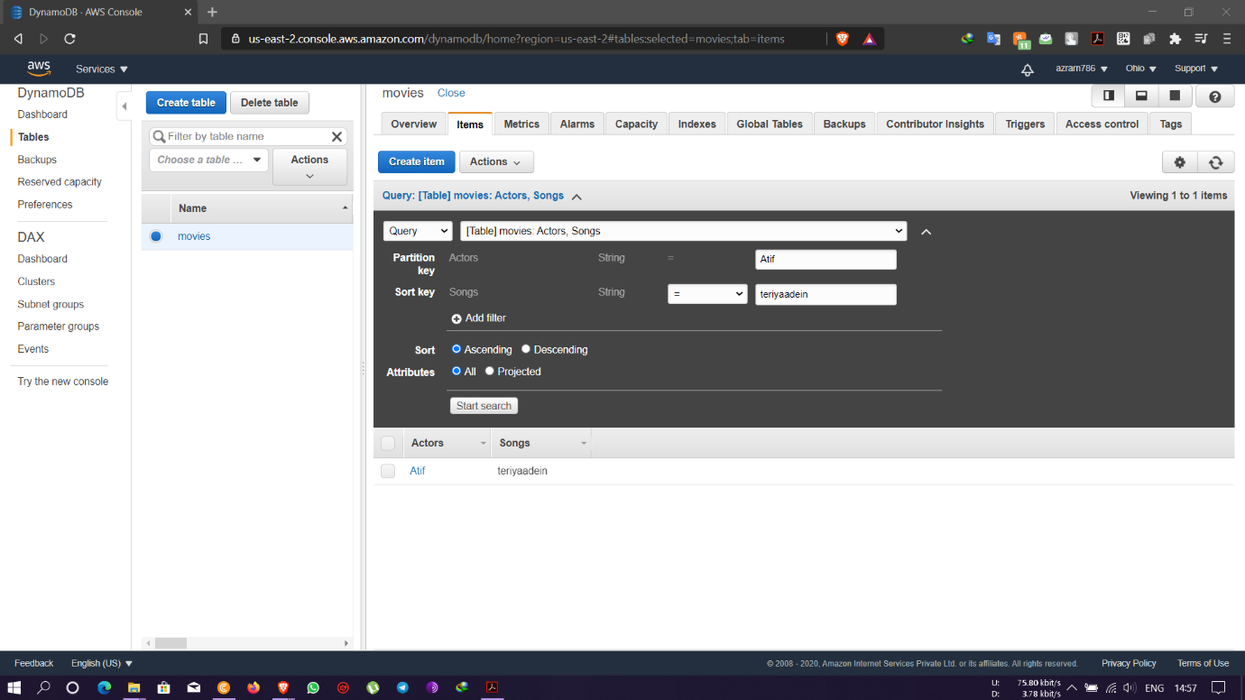

* Deletion of items from the main region – Ohio region gets deleted but in the replica regions the data are intact

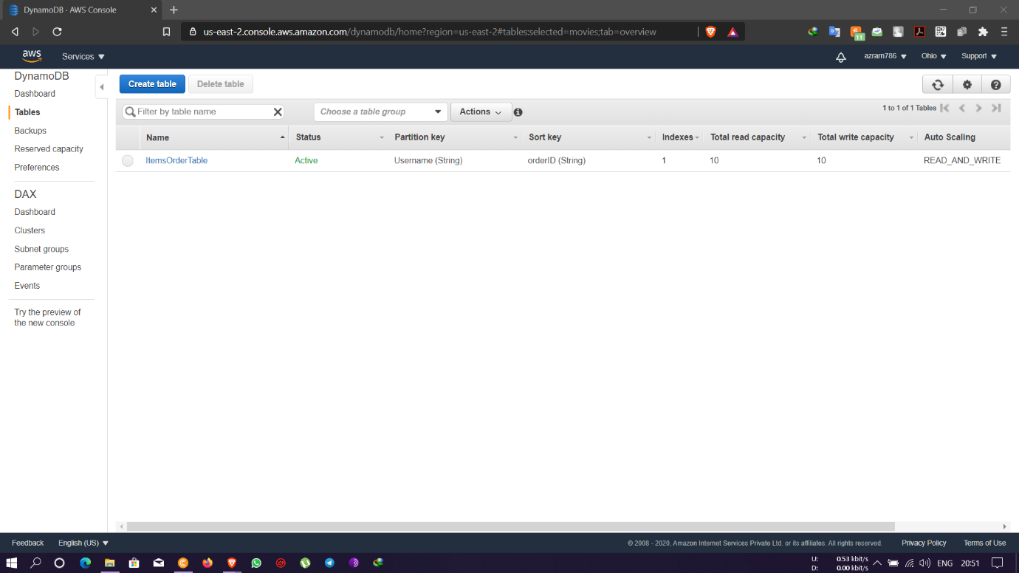

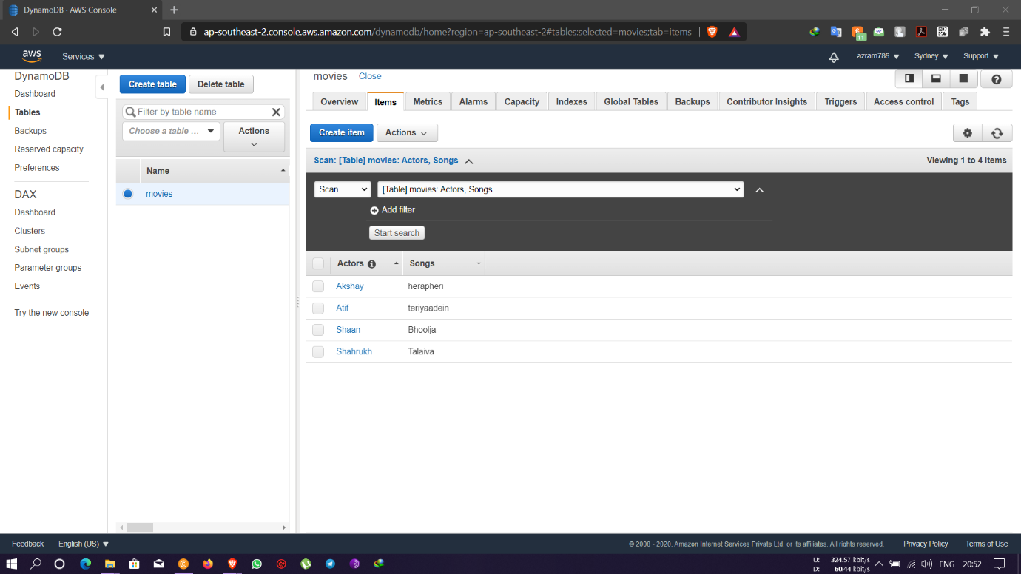

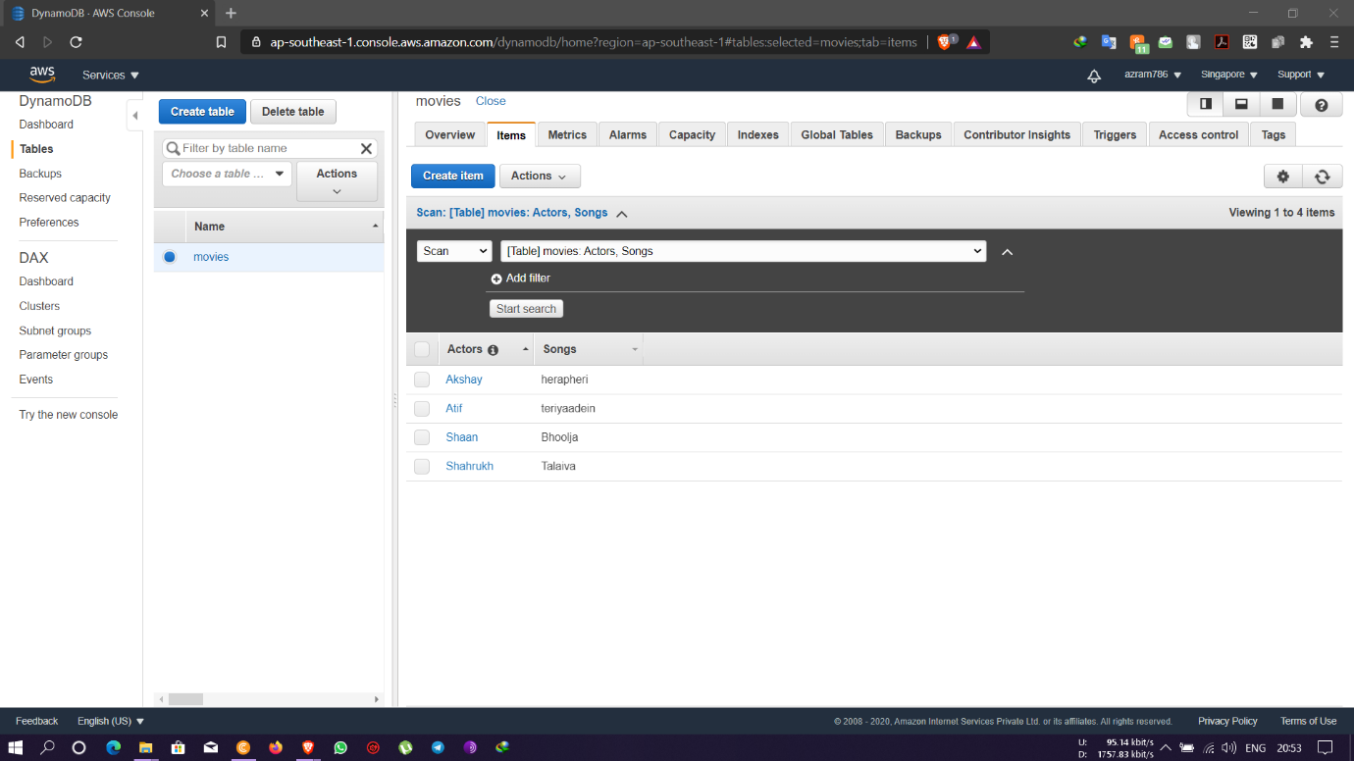

Task 2: Creating a dynamo DB table with global secondary indexes and fetching data using global

secondary indexes.

* Table created with name- ItemsOrderTable and list of items are added to it

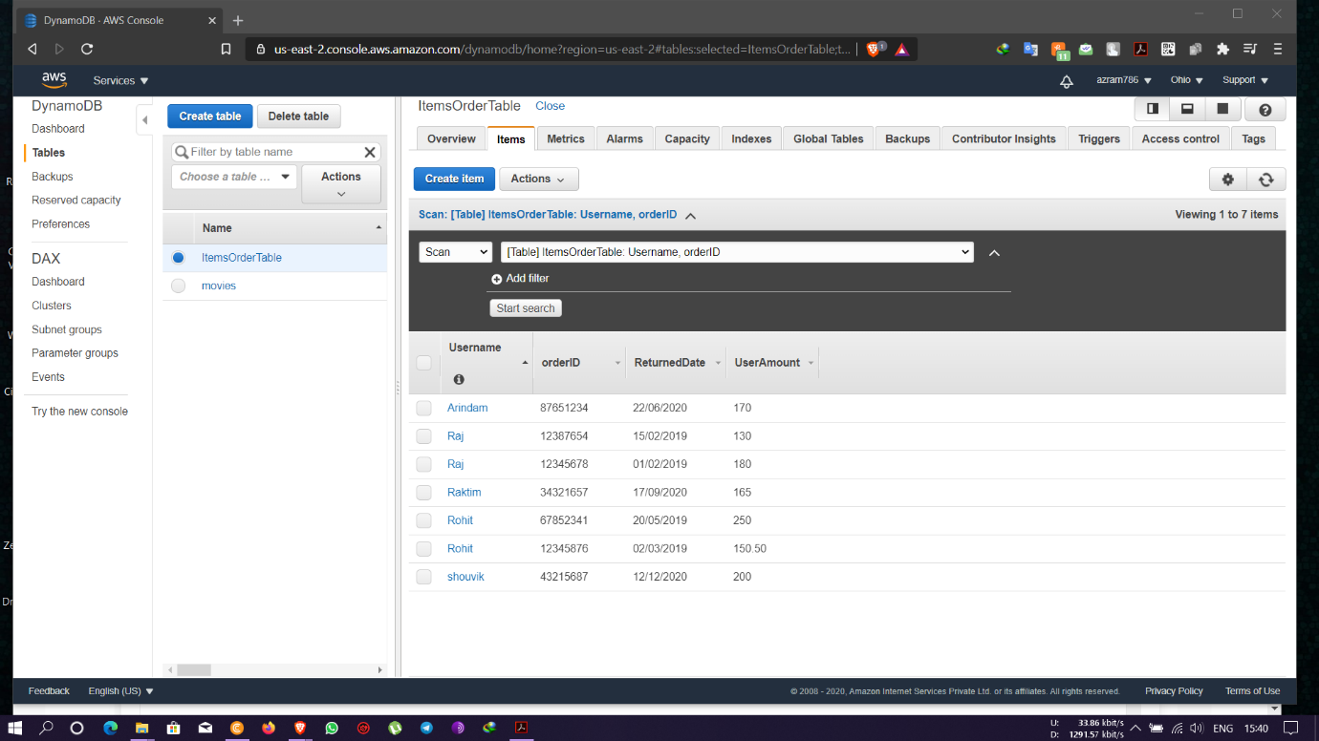

* Creation of GSI Index

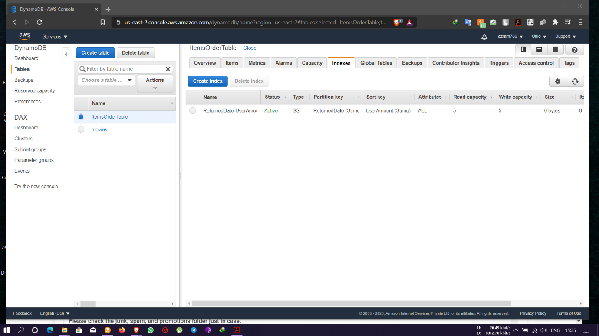

* Search query placed based on GSI index to find different items as required

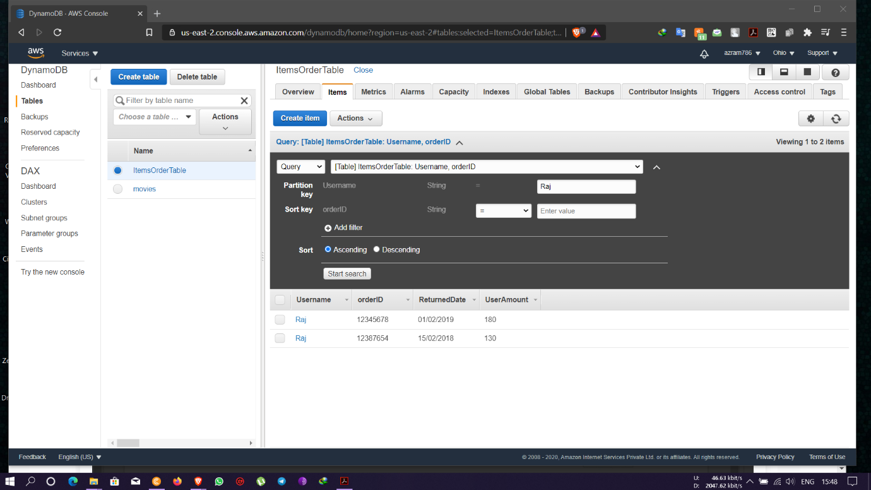

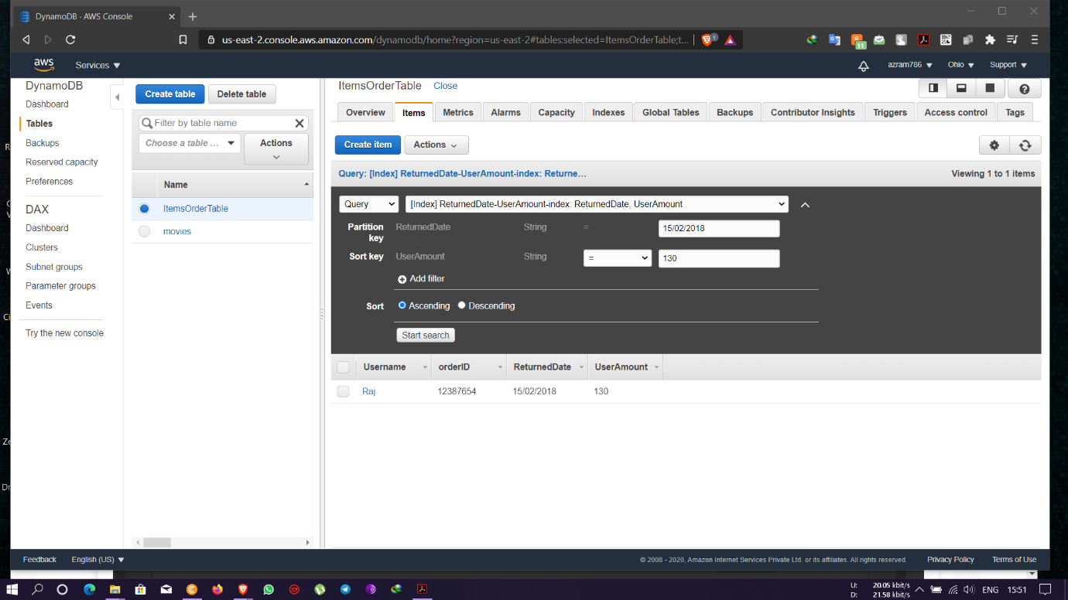

* Scan of items based on GSI index to find different items as required

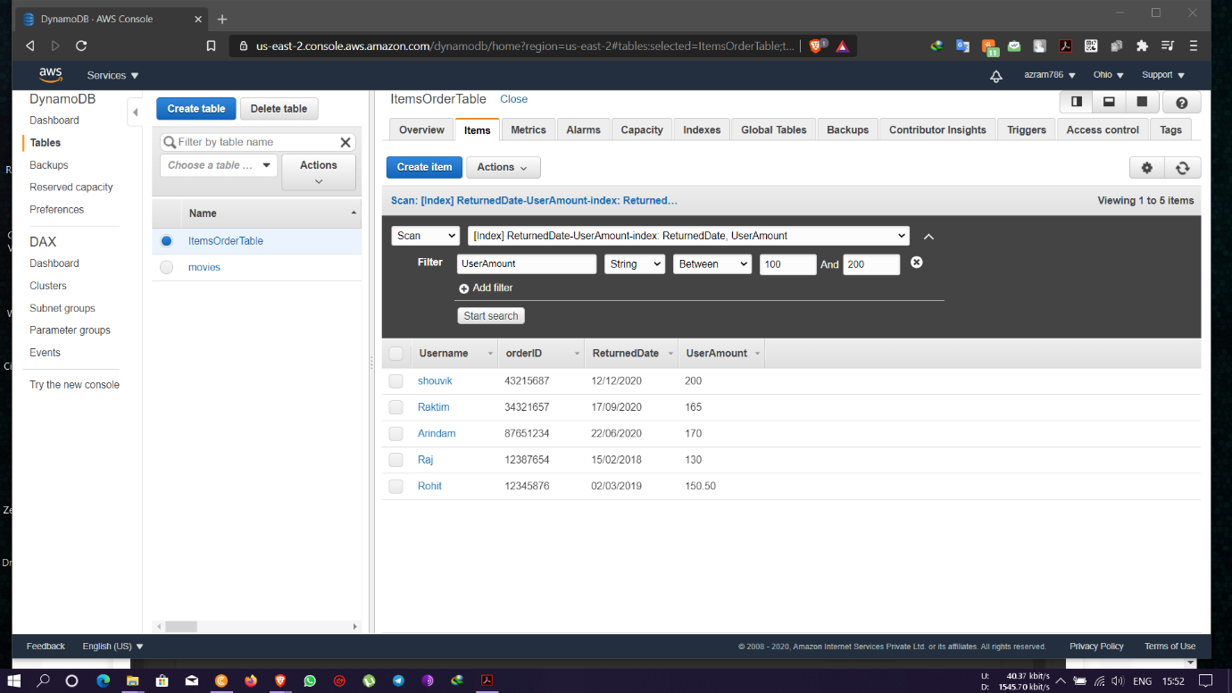

Task 3: Deploying a python application in elastic beanstalk

* Python application creation

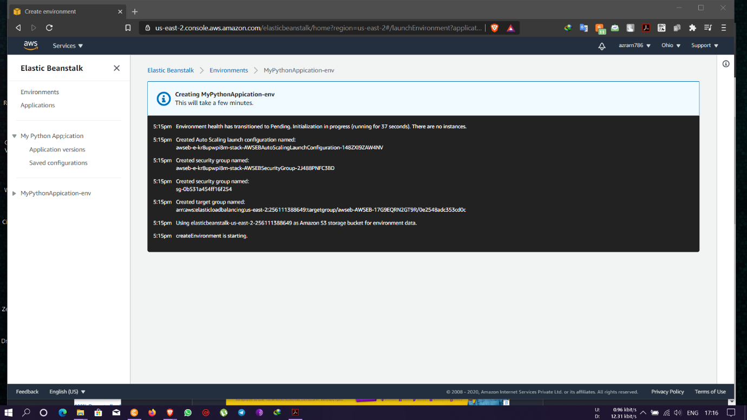

* Environments health status page

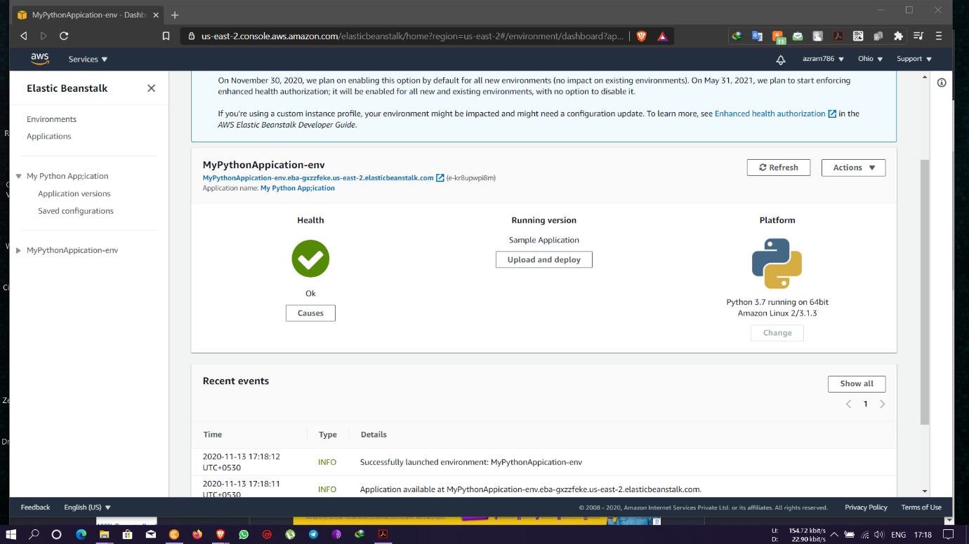

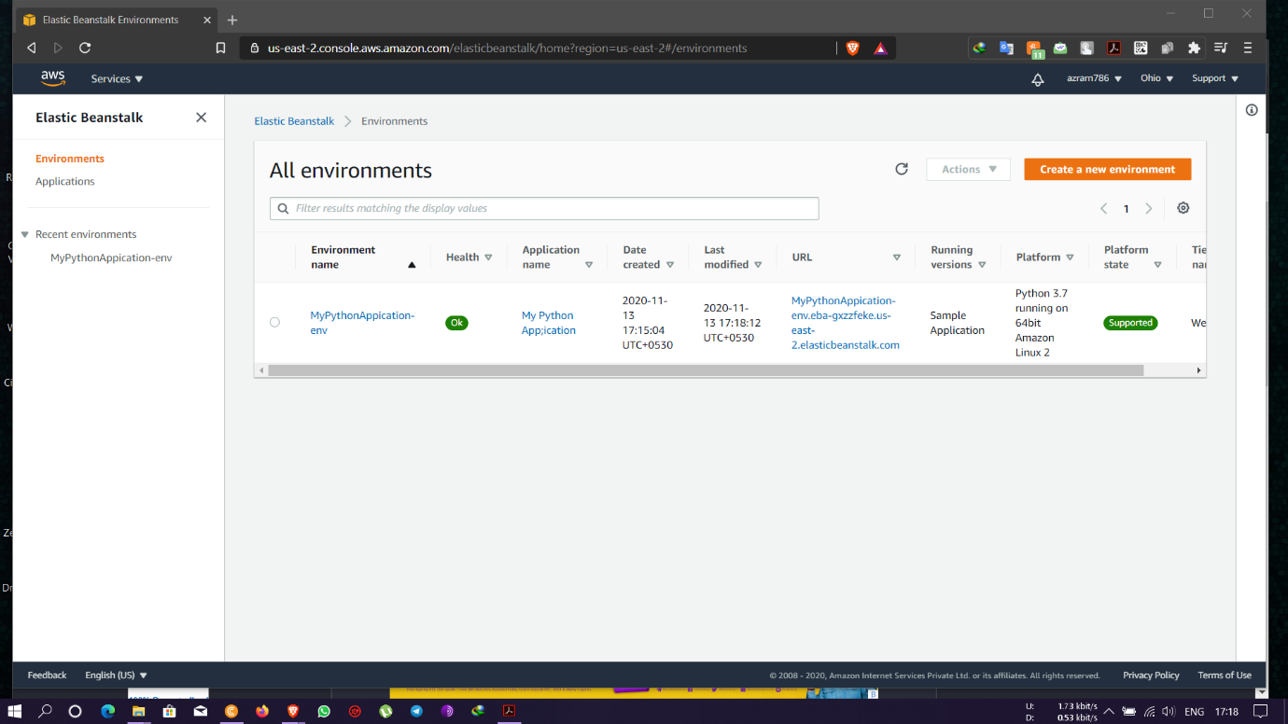

* Web page launched using the elastic beanstalk environment

